# Computer Networks Lab 6

DEEKSHA S M

RA2211026050041

CSE AIML A

## Objective

* To configure Network Address Translation (NAT) on a router using Cisco Packet Tracer
* To demonstrate the setup and configuration of NAT to allow internal network devices to communicate with external networks.

## Steps taken to set up the network

### Step 1:

Drag and drop required Network devices (2 Router-PT's and 1 Switch-PT) and End devices (2 PC-PT's and a Server-PT) as shown below.

### Step 2:

Open each Router and navigate to physical tab, and add PT-ROUTER-NM-1CGE, PT-ROUTER-NM-1S, PT-ROUTER-NM-1FFE Modules to the Router1 and add the same modules as Router1 except for PT-ROUTER-NM-1FFE, add PT-ROUTER-NM-1CGE module.

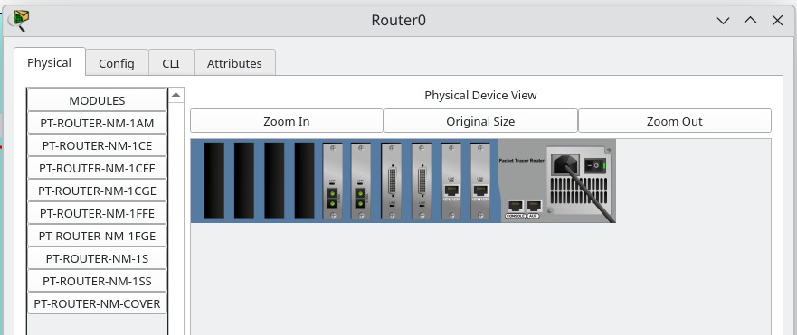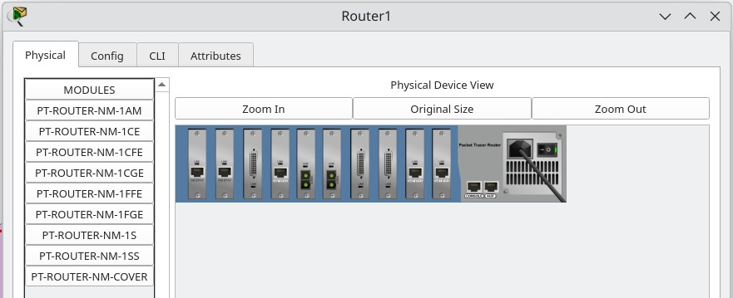

### Step 3:

Make connections using cables between all the devices as shown in the picture.

Use Copper Straight through cable to connect different devices and use a Serial DCE cable to connect ISP Router and Router 1.

### Step 4:

Now, Configure IP address of the routers and end devices according to the configuration table below;

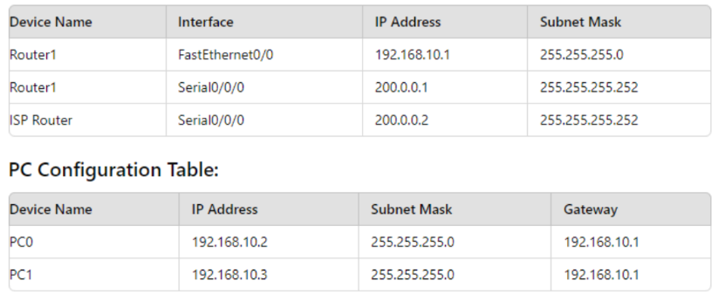

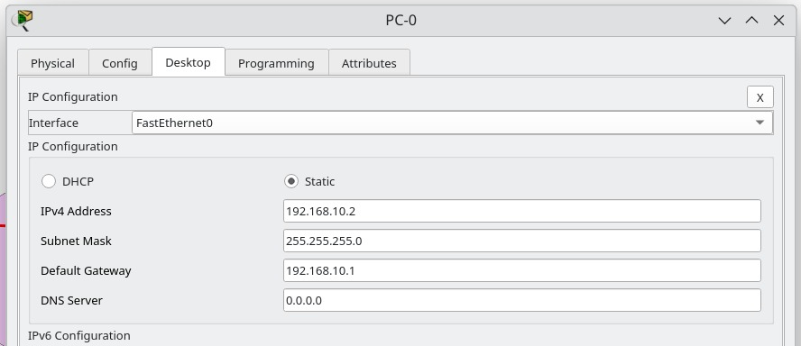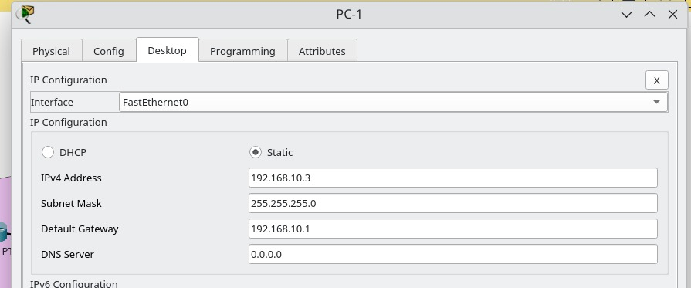

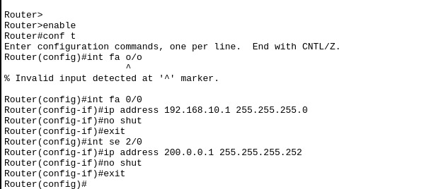

Router1

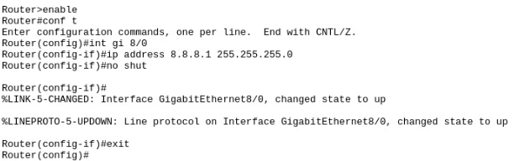 ISP Router

And configure the Ip address of the server as ;

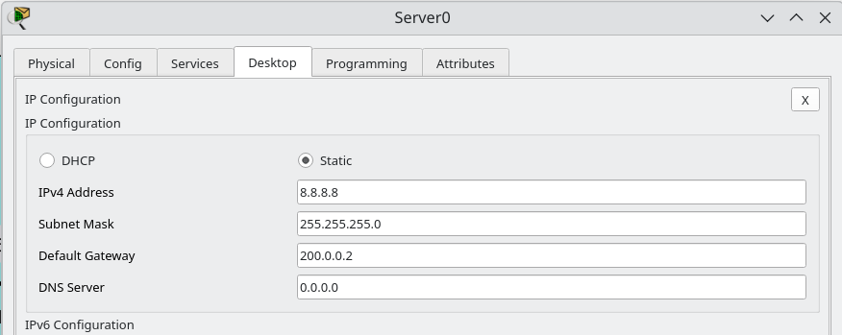

### Step 5:

We shall enable ospf routing protocol between both routers.

In Router 1;

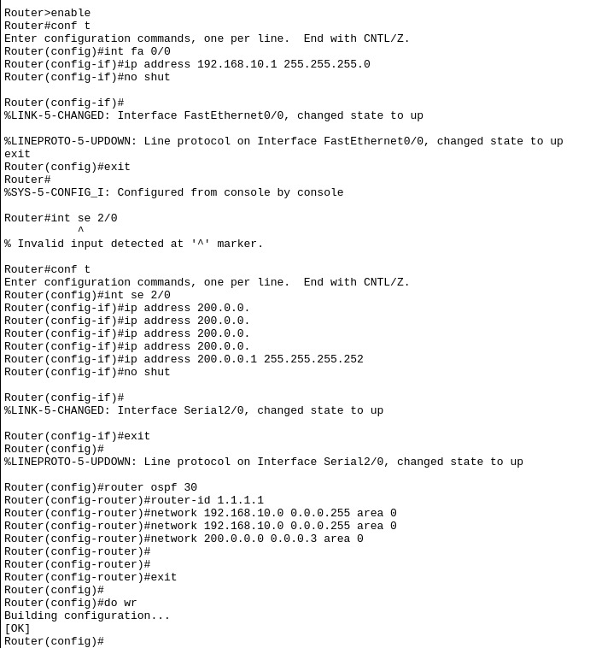

In ISP router;

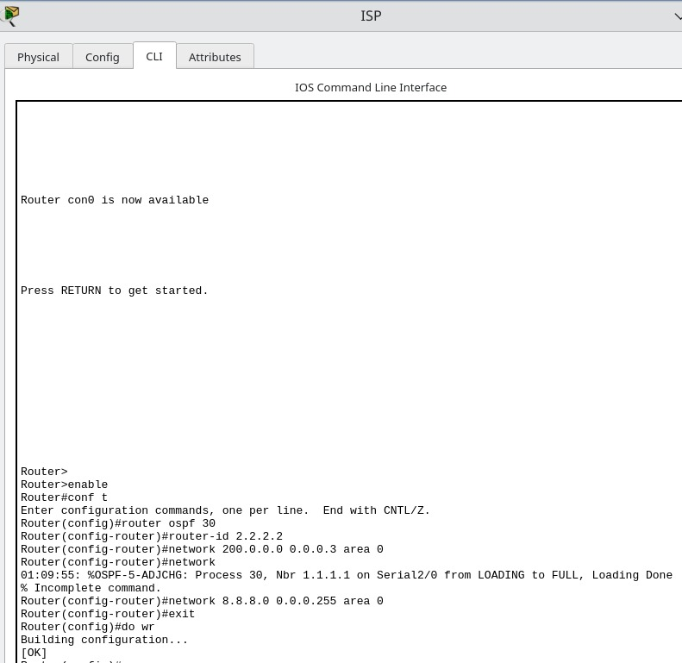

### Step 6: Ping Server (8.8.8.8) from PC-1

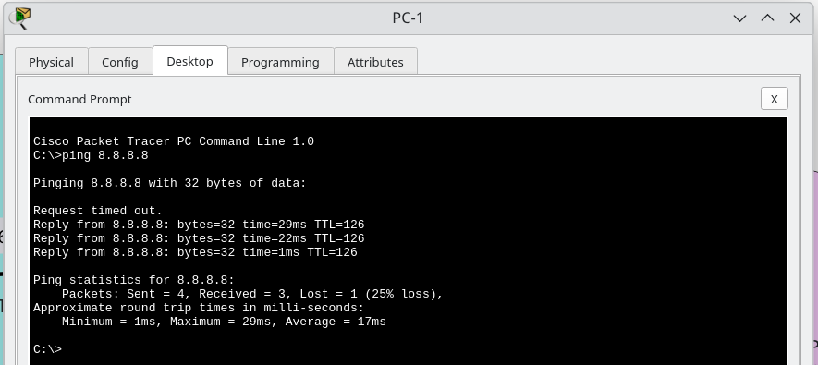

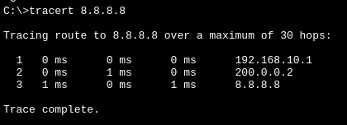

### Step 7: Check for Address Translation

### Step 8:

Configure Static NAT and configure interfaces as NAT inside and outside.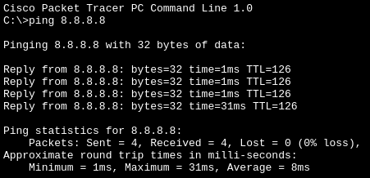

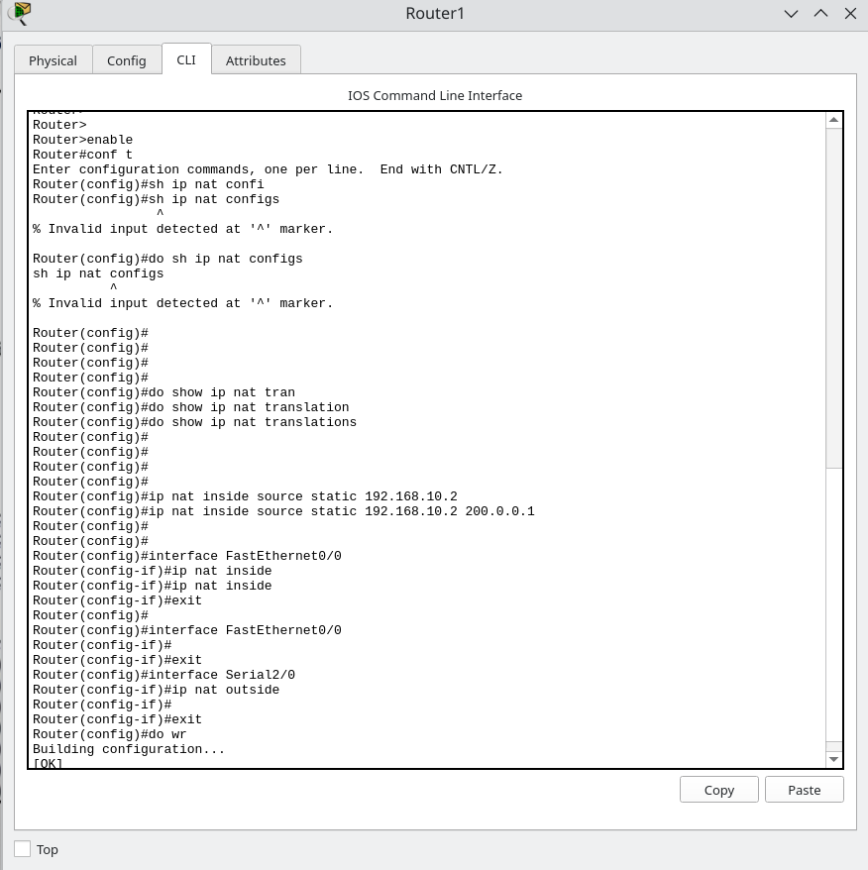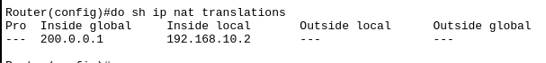

Now, let us ping again and verify the NAT;

In Router1;

